Virginia Commonwealth Chess Kids: Study Plan

Committed to Develop Young Chess Talents

Chess Ambition: To Be a Good After-School Chess Player
-Play 3-4 games a week
-Attend a chess school/club 1 time/week
-Join chess tournament 1-2 times a year

Chess Ambition: To Be a Good Scholastic Tournament Player
-Play 5-8 games a week
-Attend a chess school/club 1-2 times a week
-Studying/reading chess book independently 2-3 days a week (about 1 hour)
-Play online games (15-min time control or slower) at chesscube.com (free)
-Join chess tournament: 3-5 times a year

Chess Ambition: To Be a Strong Scholastic Tournament Player
-Play no less than 10 games a week
-Attend a chess school/club 1-2 times a week
-Studying/reading chess book independently 3-4 days a week (1-2 hours/session)
-Play online games (15-min time control or slower) at chesscube.com (free)

Chess Ambition: To Be a Competitive Local Tournament Player
-Play no less than 10 games a week
-Attend a chess school/club 1-2 times a week
-Studying/reading chess book independently at least 4 days a week
(2 hours/session)
-Play online games (15-min time control or slower) at chesscube.com (free)

Highly-Recommended Books:

- Winning Chess Strategy For Kids: Jeff Coakley 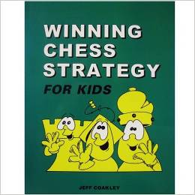
- Winning Chess Puzzles For Kids: Jeff Coakley 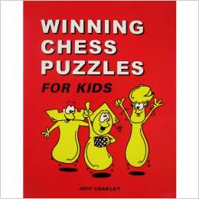

Highly-Recommended Books:

- Play Winning Chess: Yasser Seirawan 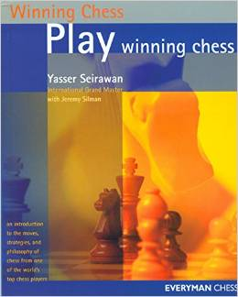
- Winning Chess Strategies: Yasser Seirawan 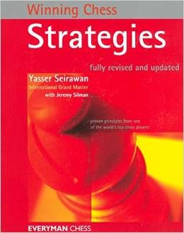

3. Logical Chess Move by Move: Irving Chernev 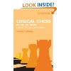
4. Chess Strategy Workbook: Todd Bardwick 